Fischer Esterification Worksheet

Student’s Name
Institutional Affiliation
Course Name & Number
Instructor’s Name
Date

Fischer Esterification Worksheet
1. Theoretical Mass yield and percent yield
The theoretical yield of the reaction is the highest amount of product anticipated after the limiting reagent is completely absorbed.
$$percent yield=\frac{actual}{theoretical}yield×100$$
$$C2H6O → C2H4+ H2O$$
$$Actual yield=28g$$
$$Theoretical yield= 46$$
$$\frac{28}{46}×100$$
$$=60.9\%$$

2. IR Analysis
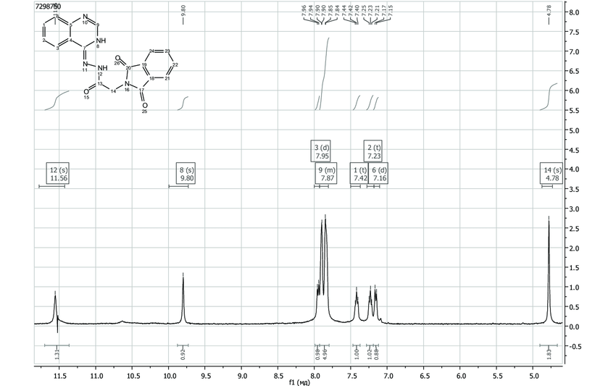
Consider the HNMR spectra provided and complete the following
Identify the phenolic hydrogen.
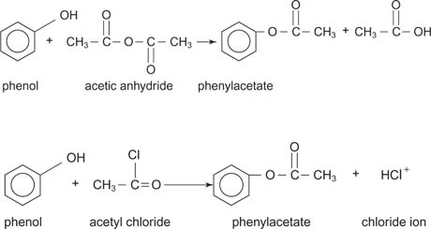
Consider the Expansion of the upfield region (60-4.5ppm) of the spectrum and determine the structure of the carbon chain of the ester.
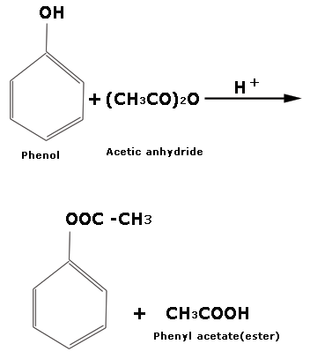
Consider the Expansion of the downfield region (56.8-8.0ppm) of the spectrum and determine the aromatic ring's substitution (ortho-, meta-, or para-). You will have to make use of your earlier knowledge of aromatic splitting patterns. (Note that the signal at 67.6 is from a CHCI, impurity in the NMR solvent.)
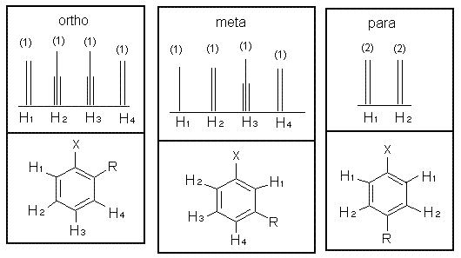
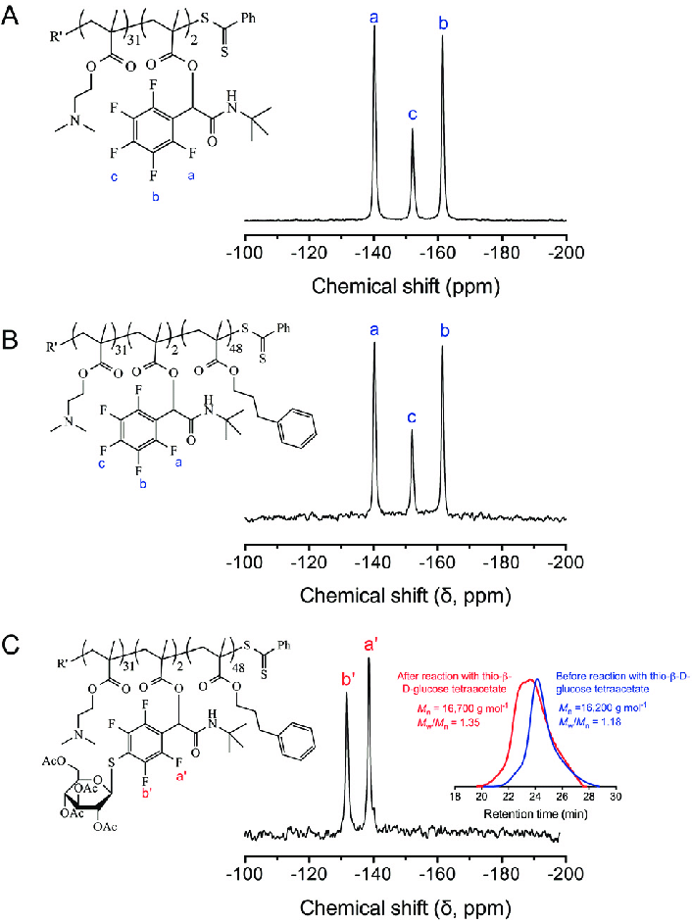
3. Print out the full HNMR (60-12ppm) spectrum and draw the determined structure of the inter onto it. Label both the H-atoms and the signals as a, b, c., etc.
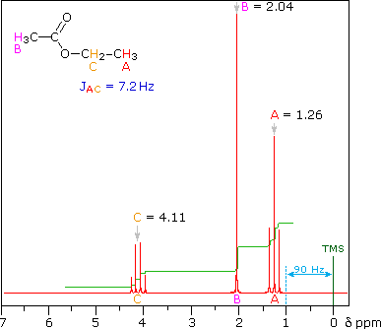
4. Did your determination of substitution by NMR analysis agree with that of your determination by IR? Which method appears to be more definitive in this case? How might that depend on the difference between the electron-donating or withdrawing properties of the substituting groups and the magnet power of the NMR used?
Yes. Nuclear NMR is a spectroscopic technique used to study atomic nuclei's magnetic fields. The intramolecular magnetic field that surrounds an atom in a molecule changes the resonant frequencies, providing detailed information of a molecule's electronic structure and distinct functional groups (Claridge, 2016).
5. Theoretical and Percent Yield
Exact Mass of carboxylic acid used=267g
Mass of 250-ml RBF=15g
Mass of RBF w/ Product=32g
Theoretical Mass Yield= 35g
$$percent yield=\frac{actual}{theoretical}yield×100$$
$$\frac{15}{35}×100$$

Percent Yield= 42.9%
6. IR Analysis
Attach the IR and fill in the IR Table below. Examine the Fingerprint Region and make your best assessment of Ortho, mate, or para- Substitution
IR Table
Functional Group | Expected Range (cm³) | Observed (cm)
Phenol | 3200-3650 | 2100-2260
Carbonyl | 3260-3330 | 1690-1760
Aromatic | 3050-3150 | 1620-1680
Ortho, meta-, or para  Substitution | 2540-3000 | 100-1200

Fingerprint region
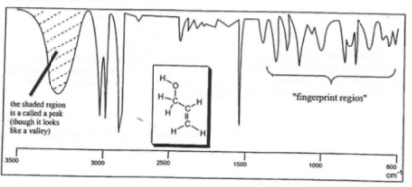
7. Print out the full HNMR (80-12ppm) spectrum and draw the determined structure of the ester onto it. Label both the H-atoms and the signals as a, b, c... etc.
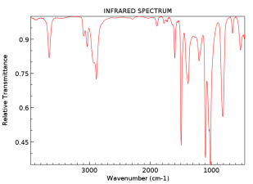
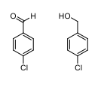
8. Did your determination of substitution by NMR analysis agree with that of your determination by IR? Which method appears to be more definitive in this case? How might that depend on the difference between the electron-donating or withdrawing properties of the substituting groups and the magnet power of the NMR used?
Yes. The most important approach for identifying the structure of organic molecules is nuclear magnetic resonance (NMR). It is the only spectroscopic approach for which a thorough study and interpretation of the entire spectrum is typically anticipated. Although greater volumes of material are required than for mass spectroscopy, NMR is non-destructive. Using current equipment, good data may be acquired from quantities measuring as little as a milligram (Boykin, 2020).

References
Boykin, D. W. (2020). 17 0 NMR Spectroscopy in Organic Chemistry.
Claridge, T. D. (2016). High-resolution NMR techniques in organic chemistry (Vol. 27). Elsevier.

